**Main Deliverable**

Collaborative or individual **AI** **Report** on:

a real-life **machine learning** **use-case** of an existing **data product** solution.

*AI accommodates & exploits “complex” human behaviour by means of automatised regulatory systems that are mechanical, biological, physical and/or cognitive in nature.*

*The necessity machine learning fall into 4 main categories:*

*When humans can’t code rules for certain problems.*

*When you need to scale a solution to millions of cases.*

*When you can do it manually, but it’s not cost-efficient.*

*When you have a massive dataset without obvious patterns.*

*A data product is any application or tool using data science combined with computing or statistical algorithms ---required by the AI-model--- that autonomously aids businesses (profit or non-profit) to provide a solution to a given societal or proprietary problem solely based on sampling data set.*

*It comprises a human-centered interface, creating meaningful insights derived from data science principles & methodologies such as:*

* *Human Factors*
* *Predictive Analytics*
* *Descriptive Data Modeling*
* *Data Mining*
* *Machine Learning*
* *Risk Management*
* *Advanced statistics*

Backbone AI Report

PART I **Problem Selection, Definition & Motivation + Human in the Loop**

Defining Artificial Intelligence (in your own words)

Why Do you Need AI? (What AI problem/use-case are you trying to solve)

Designate Capability Domain & Application Domain

Mission Statement + Definition of Done

PART II **Data (Product) Description, Preparation & Annotation**

Defining Data Science (in your own words)

Designate Data Type used

Datasets used

Data Labelling Requirements (Yes supervised ML/NO unsupervised ML)

Data Pipeline outline

Data Visualisation

Description of Data Product Components & Techniques Involved

PART III **AI Model selection, coding, training and testing**



PART IV **Critical Reflection & Ethical Considerations**

Evaluate whether the selected model solves the problem at hand

to ensure its suitability to your data-product solution.

Assess popularity / “ground-breaking-ness”

Review potential issues & existing documentation

Studied Literature

APPENDIX A:

PART I **Problem Selection, Definition & Motivation + Human in the Loop**

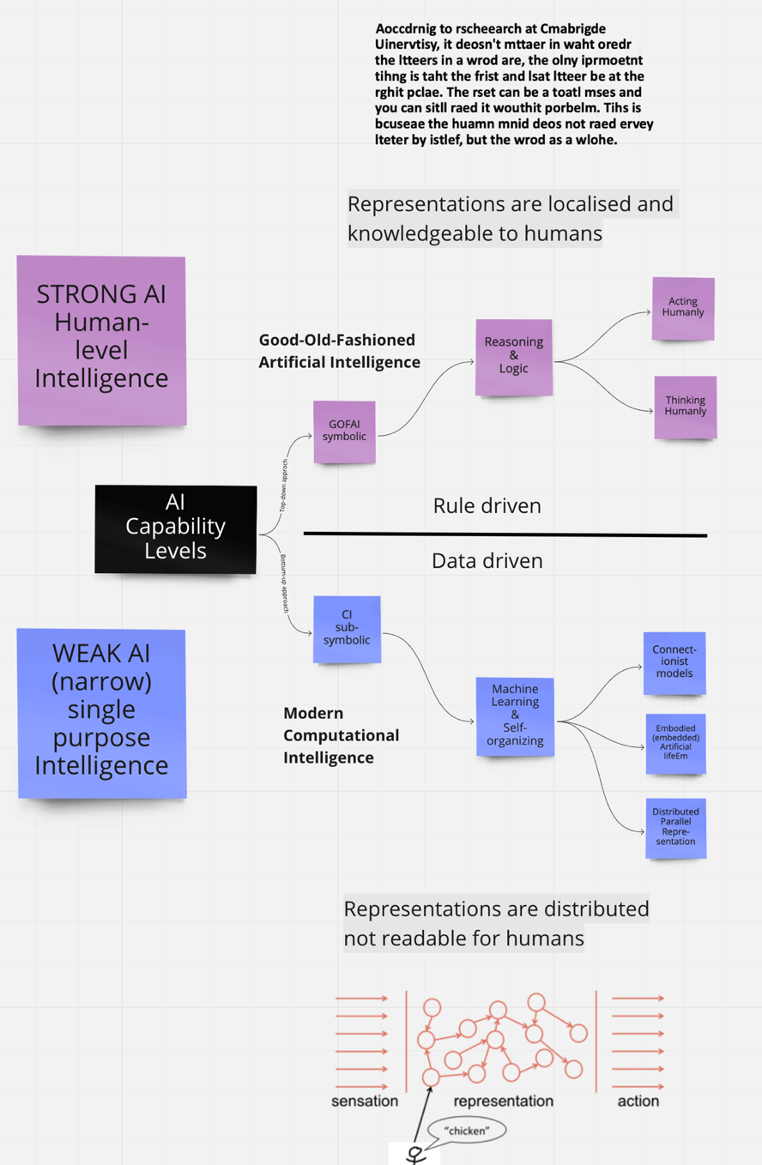



APPENDIX B:

PART II Data (Product) Description, Preparation & Annotation



APPENDIX C:

PART III **AI Model selection, coding, training and testing**

* <https://gallery.azure.ai/models>
* <https://towardsdatascience.com/top-6-deep-learning-models-you-should-master-for-killer-ai-applications-13c7dfa68a3>

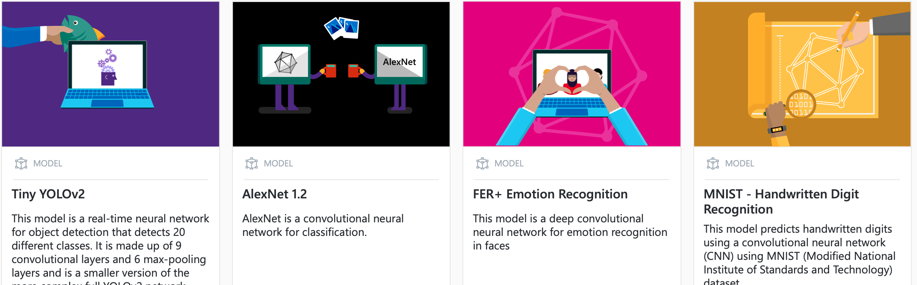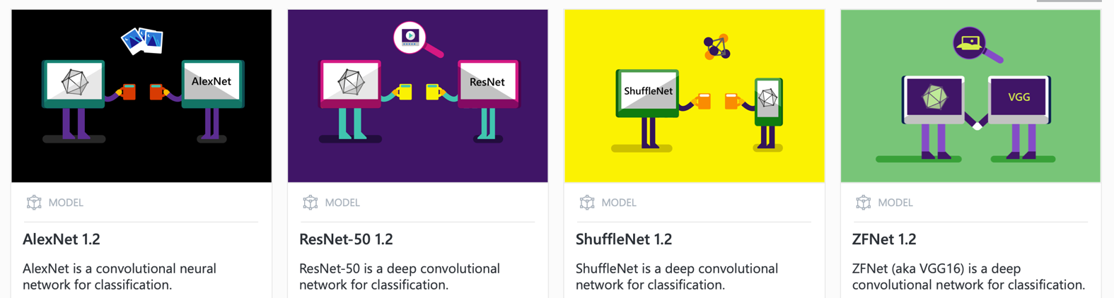

APPENDIX D:

PART IV Critical Reflection & Ethical Considerations

<https://cyber.harvard.edu/story/2019-06/introducing-principled-artificial-intelligence-project>

